Chapter 3, Solution 20

For the circuit in Fig. 3.69, find v₁, v₂, and v₃ using nodal analysis.

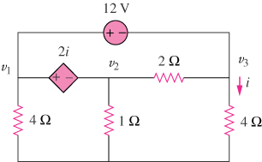

Figure 3.69
For Prob. 3.20.

Solution

Nodes 1 and 2 form a supernode; so do nodes 1 and 3. Hence
(1)

.
V₁ . V₂ 2 V₃

4 1 4

Between nodes 1 and 3,
(2)
Similarly, between nodes 1 and 2,
(3)
But . Combining this with (2) and (3) gives
. ₍₄₎

Solving (1), (2), and (4) leads to

